**Integration Testing with RecordServiceCTL**

**Description** :

With activeBookingRoomId :Enter room id and if there is an activeBookingRoomId then the state of RecordServiceUI will be set to SERVICE ,No output will be showed in unit test

Pre Condition- Active Booking Room Id should be existed

Post Condition – Nothing will be displayed

Inputs – Room Id

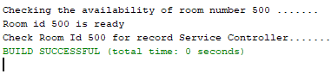

Description : Without activeBookingRoomId :Enter room id and if there is no activeBookingRoomId then The message No active booking for room id: will be displayed.

Pre Condition- Active Booking Room Id should not be existed

Post Condition – Message “No active booking for room id: ” will be displayed

Inputs – Room Id

